PUBLIC RELEASE – SY 2025-2026
FOR FREE AND REDUCED PRICE MEALS

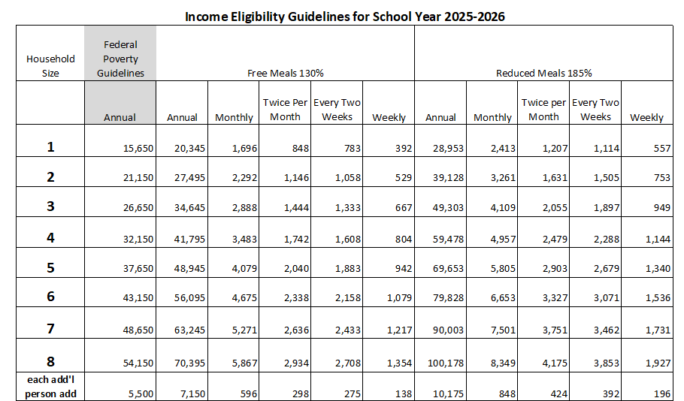
The Arkansas School for the Deaf and Blind will be participating in the National School Lunch Program and National School Breakfast Program. Households may be eligible for free or reduced price meal benefits. Applications may be found [https://linqconnect.com/public/meal-application/new?identifier=TBNGE8]. Households that participate in the Special Supplemental Nutrition Program for Women, Infants and Children (WIC) may be eligible for free or reduced price meals. To apply for free or reduced price meals, households must complete and return the application. Applications will be considered incomplete if all information is not provided as described in the instructions provided with the application. Applications may be submitted at any time during the school year as circumstances change provided that the loss of income causes the household income during the period of unemployment to be within the eligibility criteria.

Households with children who received Supplemental Nutrition Assistance Program (SNAP) benefits may submit an application with abbreviated information as described in the application instructions.

All applications are subject to verification. Parents or guardians dissatisfied with the ruling of the determining official may wish to discuss the decision with the determining official on an informal basis. Parents wishing to make a formal appeal for a hearing on the decision may make a request to: Nicole Walsh at (501) 612-8016.

Children who are enrolled in Head Start / Even Start programs are categorically eligible for free meals. Contact Penny Howard at (501) 324-9829 with questions regarding Head Start / Even Start meal benefits.

Children certified as foster, migrant, homeless or runaway by the district are categorically eligible for free meals. Contact Anna Snare at anna.snare@ade.arkansas.gov with questions regarding foster, migrant, homeless or runaway meal benefits.

Households who are notified of their eligibility but who do not want their children to receive free meals must contact the school. SNAP households should complete an application if they are not notified of their eligibility by 9/19/2025.

In the operation of child feeding programs, no child will be discriminated against because of race, sex, color, national origin, age, or disability.

Non-Discrimination Statement: This explains what to do if you believe you have been treated unfairly.
In accordance with Federal civil rights law and U.S. Department of Agriculture (USDA) civil rights regulations and policies, the USDA, its Agencies, offices, and employees, and institutions participating in or administering USDA programs are prohibited from discriminating based on race, color, national origin, religion, sex, disability, age, marital status, family/parental status, income derived from a public assistance program, political beliefs, or reprisal or retaliation for prior civil rights activity, in any program or activity conducted or funded by USDA (not all bases apply to all programs). Remedies and complaint filing deadlines vary by program or incident.

Persons with disabilities who require alternative means of communication for program information (e.g., Braille, large print, audiotape, American Sign Language, etc.) should contact the responsible Agency or USDA's TARGET Center at (202) 720-2600 (voice and TTY) or contact USDA through the Federal Relay Service at (800) 877-8339. Additionally, program information may be made available in languages other than English.

To file a program discrimination complaint, complete the USDA Program Discrimination Complaint Form, AD-3027, found online at How to File a Program Discrimination Complaint and at any USDA office or write a letter addressed to USDA and provide in the letter all of the information requested in the form. To request a copy of the complaint form, call (866) 632-9992. Submit your completed form or letter to USDA by: (1) mail: U.S. Department of Agriculture, Office of the Assistant Secretary for Civil Rights, 1400 Independence Avenue, SW, Washington, D.C. 20250-9410; (2) fax: (202) 690-7442; or (3) email: program.intake@usda.gov.

USDA is an equal opportunity provider, employer, and lender.

